**Міністерство освіти і науки України**

**Національний технічний університет України**

**“Київський політехнічний інститут”**

**Факультет прикладної математики**

**Кафедра спеціалізованих комп’ютерних систем**

**Лабораторна робота № 4**

з дисципліни «Схемотехніка»

«Проектування лічильників на потенціальних елементах»



Виконав :

Студент групи КВ-32

**Сидоренко Владислав**

Перевірив:

Клятченко Я.М.

____________________________________

Київ 2015

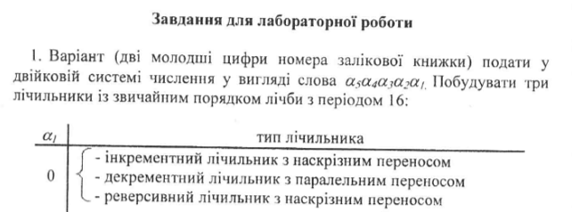

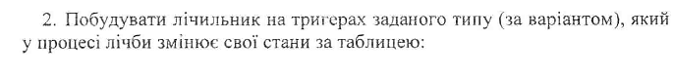

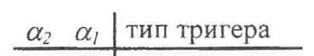

Стани лічильника

|  |  |  |  |
| --- | --- | --- | --- |
| Q4 | Q3 | Q2 | Q1 |
| 0 | 0 | 0 | 0 |
| 0 | 0 | 1 | 0 |
| 0 | 0 | 1 | 1 |
| 0 | 1 | 0 | 1 |
| 0 | 1 | 1 | 0 |
| 1 | 0 | 0 | 0 |
| 1 | 0 | 1 | 0 |
| 1 | 0 | 1 | 1 |
| 1 | 1 | 0 | 1 |
| 1 | 1 | 1 | 0 |

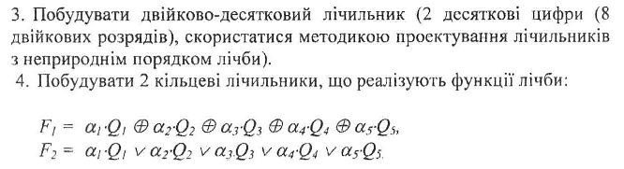

1. Побудувати 3 лічильники зі звичайним порядком лічби з періодом 16

- Інкрементний лічильник з наскрізним переносом

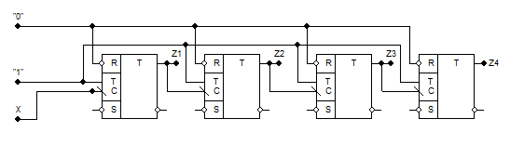

- Декрементний лічильник з паралельним переносом

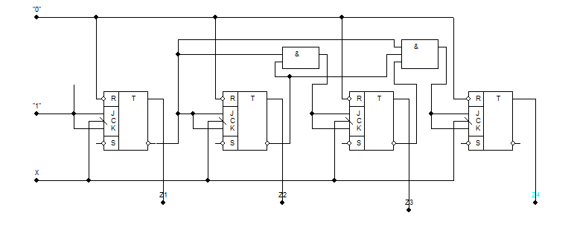

- Реверсивний лічильник з наскрізним переносом

$\left\{\begin{aligned}F1=1 \\ F2=F2^{'} ∨ F2\text{ , F2' = YQ1 , F2}\text{"}=\left(\overline{Y}\right)\left(\overline{Q1}\right);… \\ F4=F4^{'}∨ F4\text{ , F4' = F3'Q3' , F4}\text{"}=(\overline{F3"})(\overline{Q3}).\end{aligned}\right.$

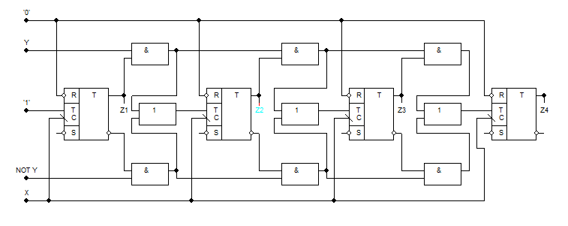

2.

|  |  |  |  |  |  |  |  |  |  |  |  |
| --- | --- | --- | --- | --- | --- | --- | --- | --- | --- | --- | --- |
| Q4 | Q3 | Q2 | Q1 | FJ4 | FK4 | FJ3 | FK3 | FJ2 | FK2 | FJ1 | FK1 |
| 0 | 0 | 0 | 0 | 0 | * | 0 | * | 1 | * | 0 | * |
| 0 | 0 | 1 | 0 | 0 | * | 0 | * | * | 0 | 1 | * |
| 0 | 0 | 1 | 1 | 0 | * | 1 | * | * | 1 | * | 0 |
| 0 | 1 | 0 | 1 | 0 | * | * | 0 | 1 | * | * | 1 |
| 0 | 1 | 1 | 0 | 1 | * | * | 1 | * | 1 | 0 | * |
| 1 | 0 | 0 | 0 | * | 0 | * | 0 | 1 | * | 0 | * |
| 1 | 0 | 1 | 0 | * | 0 | * | 0 | * | 0 | 1 | * |
| 1 | 0 | 1 | 1 | * | 0 | 1 | * | * | 1 | * | 0 |
| 1 | 1 | 0 | 1 | * | 0 | * | 0 | 1 | * | * | 1 |
| 1 | 1 | 1 | 0 | * | 1 | * | 1 | * | 1 | 0 | * |

|  |  |  |  |
| --- | --- | --- | --- |
| 0 | * | * | * |
| * | * | * | 0 |
| 1 | * | * | * |
| 0 | * | * | 0 |

|  |  |  |  |
| --- | --- | --- | --- |
| * | 0 | * | * |
| * | * | 0 | * |
| * | 1 | * | * |
| * | 0 | 0 | * |

FJ4 = not(Q1)*Q3 FK4 = not(Q1)*Q3

|  |  |  |  |
| --- | --- | --- | --- |
| 1 | 1 | * | * |
| * | * | * | * |
| * | * | * | * |
| 0 | * | * | 0 |

|  |  |  |  |
| --- | --- | --- | --- |
| * | * | * | * |
| * | * | 0 | 0 |
| 1 | 1 | * | * |
| * | 0 | 0 | * |

FJ3 = 1 FK3 = not(Q1)*Q3

|  |  |  |  |
| --- | --- | --- | --- |
| * | * | * | * |
| * | * | 1 | 1 |
| * | * | * | * |
| * | * | 1 | 1 |

|  |  |  |  |
| --- | --- | --- | --- |
| 1 | 1 | * | * |
| * | * | * | * |
| 1 | 1 | * | * |
| 0 | 0 | * | * |

FJ2 = 1 FK2 = Q1 v not(Q1)*Q3

|  |  |  |  |
| --- | --- | --- | --- |
| * | * | * | * |
| * | * | * | * |
| 0 | 0 | * | * |
| 1 | 1 | 0 | 0 |

|  |  |  |  |
| --- | --- | --- | --- |
| 0 | 0 | * | * |
| * | * | 1 | 1 |
| * | * | * | * |
| * | * | * | * |

FJ1 = not(Q1)*Q2*not(Q3) FK1 = not(Q2)

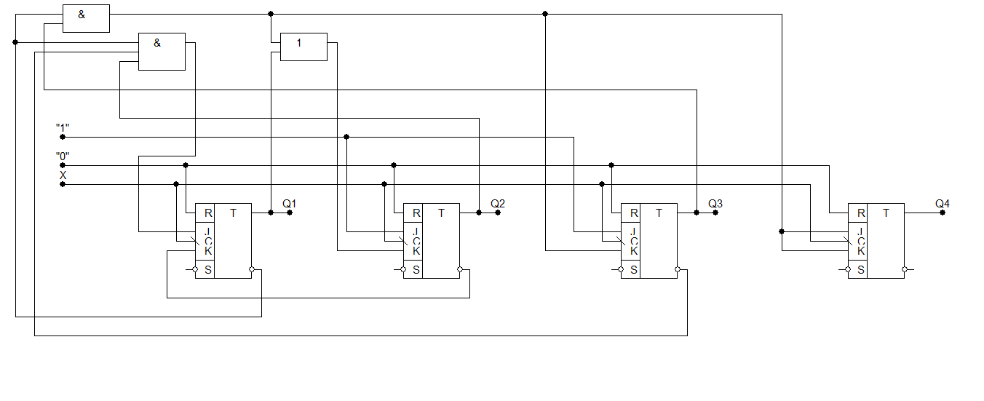

3.

|  |  |  |  |  |  |  |  |
| --- | --- | --- | --- | --- | --- | --- | --- |
| Q4 | Q3 | Q2 | Q1 | T4 | T3 | T2 | T1 |
| 0 | 0 | 0 | 0 | 0 | 0 | 0 | 1 |
| 0 | 0 | 0 | 1 | 0 | 0 | 1 | 1 |
| 0 | 0 | 1 | 0 | 0 | 0 | 0 | 1 |
| 0 | 0 | 1 | 1 | 0 | 1 | 1 | 1 |
| 0 | 1 | 0 | 0 | 0 | 0 | 0 | 1 |
| 0 | 1 | 0 | 1 | 0 | 0 | 1 | 1 |
| 0 | 1 | 1 | 0 | 0 | 0 | 0 | 1 |
| 0 | 1 | 1 | 1 | 1 | 1 | 1 | 1 |
| 1 | 0 | 0 | 0 | 0 | 0 | 0 | 1 |
| 1 | 0 | 0 | 1 | 1 | 0 | 0 | 1 |

|  |  |  |  |
| --- | --- | --- | --- |
| * | * | 1 | 0 |
| * | * | * | * |
| 0 | 1 | 0 | 0 |
| 0 | 0 | 0 | 0 |

T4 = Q1Q4 or Q2 Q3 Q4

|  |  |  |  |
| --- | --- | --- | --- |
| * | * | 0 | 0 |
| * | * | * | * |
| 0 | 1 | 1 | 0 |
| 0 | 0 | 0 | 0 |

T3 = Q3 Q4

|  |  |  |  |
| --- | --- | --- | --- |
| * | * | 0 | 0 |
| * | * | * | * |
| 0 | 1 | 1 | 0 |
| 0 | 1 | 1 | 0 |

T2 = notQ1 Q4

T1 = “1”

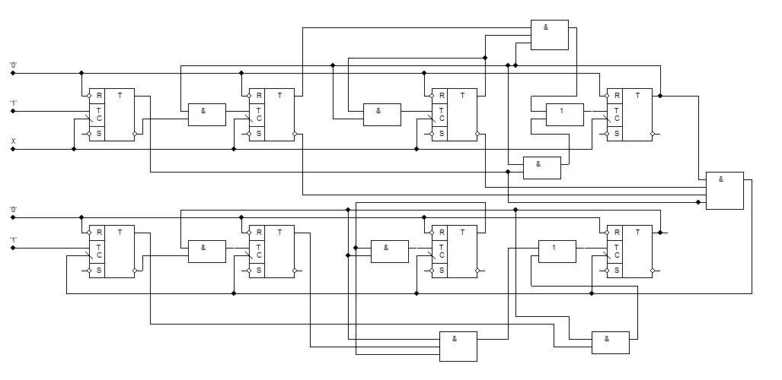

4.

F1 = Q2 $⨁$ Q4

F2 = Q2 $∨$ Q4

